Name: poorab gangwani__________________

Section: ___2b______________

Enrollment #: _cs191092____________

**LAB # 1**

**FOR LAB 1 ,MADAM TOLD TO JUST ATTEMPT Q1 IN THE post lab assignment and leave out post lab tasks 1 and 2**

**Introduction to Workbench Apparatus and Common Electrical & Electronic Circuit Symbols**

**Lab Objectives:**

* To learn how to use the apparatus placed on the electronic workbench.

(Breadboard, DC Power Supply, Function Generator, Oscilloscope, Desktop Multi-meter, Digital Multi-meter)

* To learn about various commonly used electrical and electronic circuit symbols.

**PRE-LAB:**

**A. Introduction to Lab Apparatus:**

On each workbench, the following apparatus is present:

1. **Breadboard:**



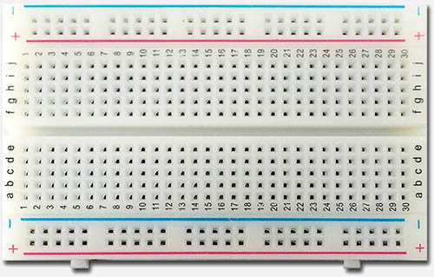



Section I

These are connected together vertically



Section II

These are connected together horizontally

*Fig. 1.1: Breadboard*

The diagram shown on the previous page is that of the circuit construction area on the prototyping board. This area is used to construct a circuit according to the circuit schematic.

Section I: The holes in these sections are connected vertically. Moreover, the column of holes between the ‘+’ signs are connected. These are the holes adjacent to the red vertical stripe. Likewise the holes located between the ‘-’ signs are connected. These holes are adjacent to the vertical blue line. There is no electrical connection of these holes horizontally.

Section II: The holes at this location are electrically connected horizontally. Each row of holes is connected on each side of the groove or trough. The groove isolates one row of holes from the other horizontally. There is no electrical connection of any of these holes in the vertical direction. Each column of holes in this section is not connected. Since there are more holes in this section, construction of the circuit to be analyzed or designed is reserved for this area.

1. **DC Power supply:**

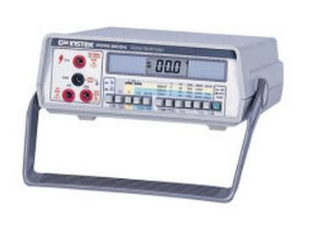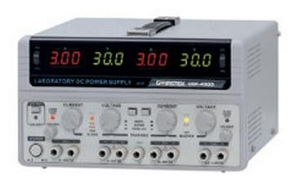A DC power supply is used to supply voltage to an electric circuit. The DC power supply available on the workbench has two built-in variable power supplies ranging from 0-30V, which can be connected in series or parallel. In addition to the two variable power supplies, there is also a fixed +5V supply.

*Fig 1.2: DC Power supply*  *Fig 1.3: Desktop multi-meter*

1. **Desktop Multi-meter:**

The desktop multi-meter placed on the workbench is used for measuring voltage, current, resistance & capacitance. Before measuring any electrical quantity, the appropriate range has to be selected.

1. **Function Generator:**

A function generator is an electronic equipment used to generate different types of electrical waveforms with varying frequencies. Fig 1.4 shows a typical function generator.

1. **Digital Oscilloscope:**

A digital oscilloscope is an electronic instrument that allows time varying signals to be viewed on a two dimensional graph. The signal’s amplitude is plotted along the vertical axis as a function of time in seconds, which is plotted along the horizontal axis. Fig 1.5 shows a typical oscilloscope.

Most oscilloscopes have at least two input channels and each channel can display a waveform on the screen.

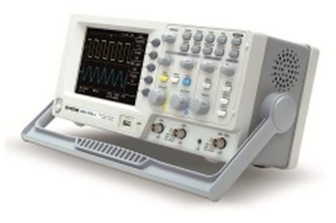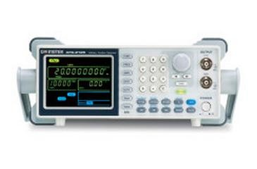

*Fig 1.4: Function generator* *Fig 1.5: Digital Oscilloscope*

Fig 1.6 shows how a typical sinusoidal waveform would appear on the oscilloscope’s screen.

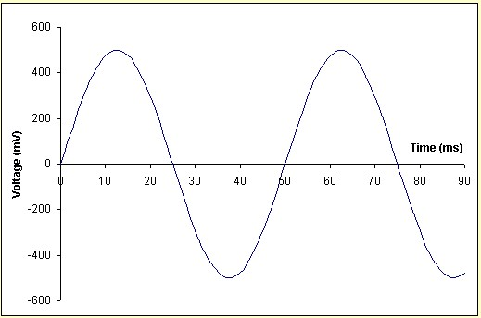

*Fig 1.6: A typical sinusoidal waveform*

The ‘volts per division’ on the vertical axis and ‘time per division’ along the horizontal axis are set using the control knobs on the oscilloscope’s front panel

In Fig 1.7, the sine wave’s peak voltage equals 2.5 divisions along the vertical axis. Assuming that the ‘volts per division’ knob is set to 5V per division, the waveform’s peak voltage would be 5 V x 2.5 = 12.5 V.

In Fig 1.8, each time period of the sine wave includes 5 divisions along the horizontal axis. Assuming that the ‘time per division’ knob is set to 1ms, the sine wave’s time period would equal 5 x 1 ms = 5 ms.

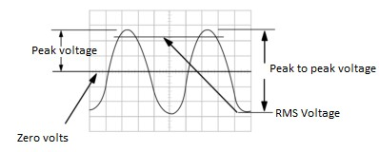

*Fig 1.7: AC waveform*

…………………………………………. eq. 1.1

*..…………………………..... eq. 1.2*

*……………………………...…….. eq. 1.3*

The time period of a waveform is defined as the time after which the waveform repeats itself or the time taken by the waveform to complete one cycle

**B. Commonly used Electrical and Electronic Circuit Symbols:**

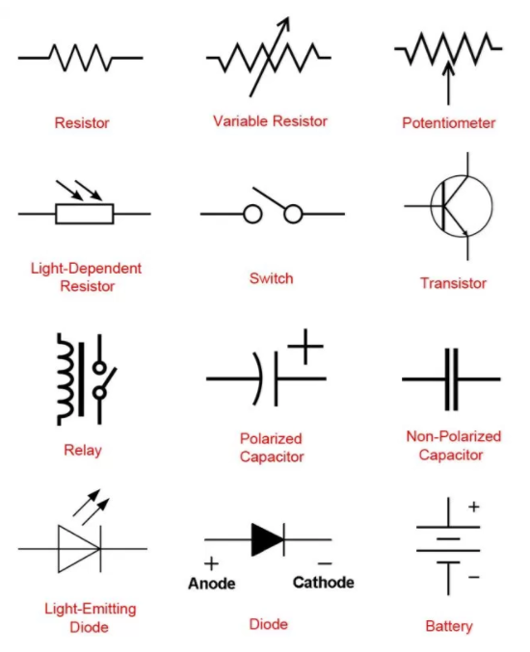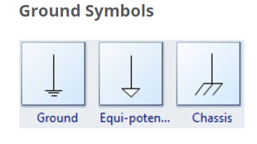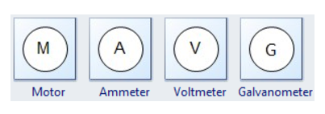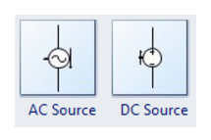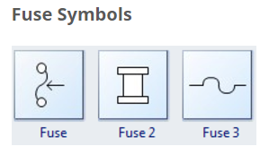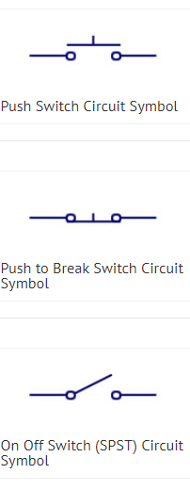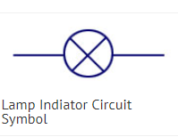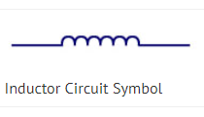

*Fig 1.8: Electrical & electronics symbols*

Name: __________________

Enrollment #: _____________

**POST-LAB ASSIGNMENT # 1:**

**LAB TASK 1:**

1. Connect function generator output at the input of Oscilloscope at channel 1 or at channel 2

2. Select proper channel i.e. if signal is connected to channel 1 select CH1 and if signal is connected to channel 2 select CH2

3. Adjust Time /Div. knob to get sufficient time period displacement of the wave on the Oscilloscope screen.

4. Use triggering controls if waveform is not stable

5. Keep volt/div knob such that waveform is visible on the screen without clipping.

6. Measure P-P (peak to peak) reading along y-axis. For this measure vertical division. This division multiplied by volt/div gives amplitude of the wave.

7. Measure horizontal division of one complete cycle. This division multiplied by time/div gives time period of the wave.

*Table 1.1: Lab task 1*

|  |  |  |  |  |  |  |  |
| --- | --- | --- | --- | --- | --- | --- | --- |
| Function | Vertical divisions  (a) | Volts/div  (b) | Amplitude  (p-p)  V=a*b | Horizontal divisions  (c) | Time/div  (d) | Time  T=c*d | Frequency  f=1/T |
| SINE WAVE |  |  |  |  |  |  |  |
| TRIANGULAR WAVE |  |  |  |  |  |  |  |
| SQUARE WAVE |  |  |  |  |  |  |  |

**LAB TASK 2:** Draw the observed waveforms with amplitude and frequency values.

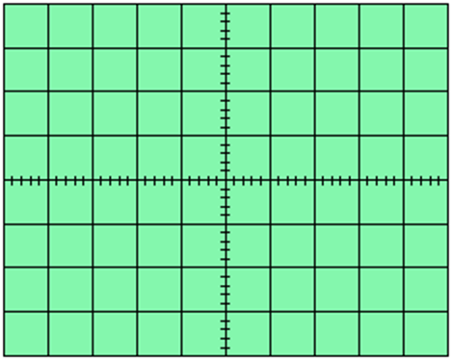

Wave type = __________________

Amplitude = ____________ Volts/div= ________

Frequency= ____________ Time/div=_________



Wave type = __________________

Amplitude = ____________ Volts/div= ________

Frequency= ____________ Time/div=_________



Wave type = __________________

Amplitude = ____________ Volts/div= ________

Frequency= ____________ Time/div=_________

Q.1 Identify the following symbols

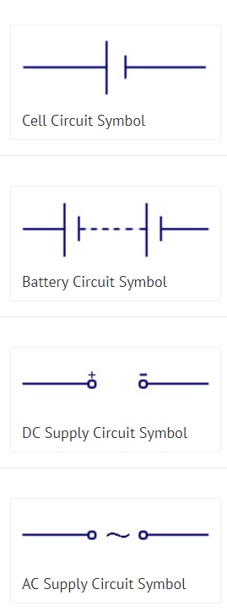1. AC SOURCE

2. DC SOURCE

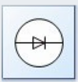

3. DIODE

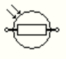

4. LDR

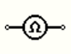5. OHMMETER